# DAD 220 Module Four Lab Template

## Overview

Begin by doing the following steps in the IDE (Codio):

1. Load the classicmodels data set.
2. Start a new terminal session and run this command: mysqlsampledatabase.sql
3. Write commands to use the classicmodels database and show its tables to verify that you are in the right place.

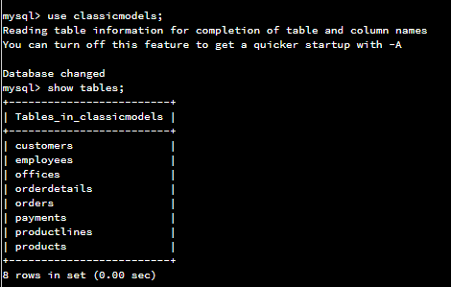

Then perform the steps below to complete the lab. Manually enter any commands you are asked to write. At the end of each step, replace the bracketed text in this template with your screenshot, response, or both, as indicated. Submit your completed template for grading and feedback. Screenshots should be sized to about one-quarter of a page. Written responses should be in complete sentences. Rename this document by adding your last name to the file name before you submit it.

## Identify Cardinality and Table Relationships

1. **Retrieve employee tuples and identify the number of employees** in San Francisco and New York.
   1. Command for San Francisco: select firstName, lastName, jobTitle, offices.city from employees inner join offices on employees.officeCode = offices.officeCode where state = 'CA'.
   2. Write and run a command to return records from New York on your own.
   3. Validate the completion of this step with a screenshot of these two tables.

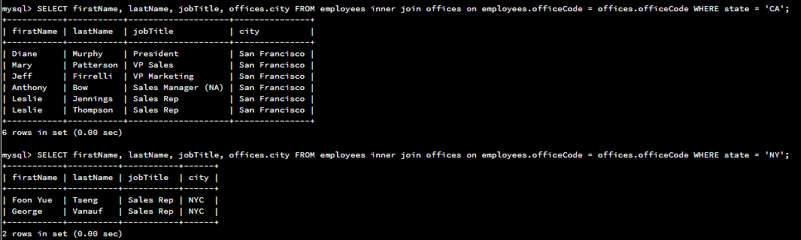

1. **Retrieve order details** for orderNumber 10330, 10338, and 10194 and **identify** what **type of cardinality** this represents in the entity relationship model.
   1. Retrieve the order details by running SELECT queries with WHERE clauses against the Orders table.

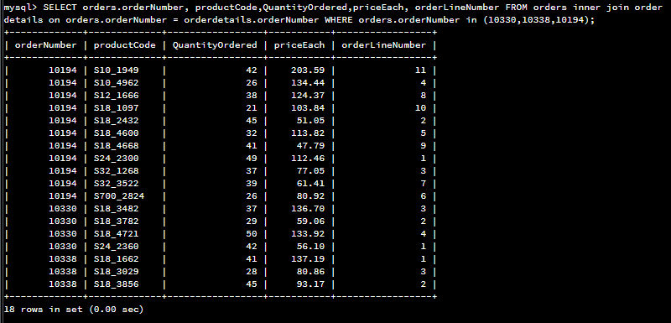

* 1. Now, identify what type of cardinality this represents in the entity relationship model.

This is a one-many cardinality as there can be many items on a single order.

1. **Delete records** from the payments table where the customer number equals 103.
   1. Run a DESCRIBE statement to identify fields in the Payments table first. You are creating a file with any name you choose.
   2. Select the records from the Payments table for customer number 103 before deleting them.

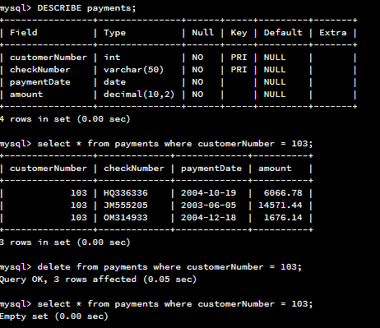

* 1. Delete the records from the Payments table for customer number 103.
  2. Run a SELECT statement against the table to show that customer number 103 is no longer there.



1. **Retrieve customer records** for sales representative Barry Jones and **identify** if the **relationships** are one-to-one or one-to-many**.**
   1. Remember: SELECT, FROM, INNER JOIN, and WHERE.
   2. Use Barry’s employeeNumber, 1504, and perform a join between the customer salesRepEmployeeNumber to retrieve these records.
      1. Identify whether these entities demonstrate one-to-one or many-to-many relationships.

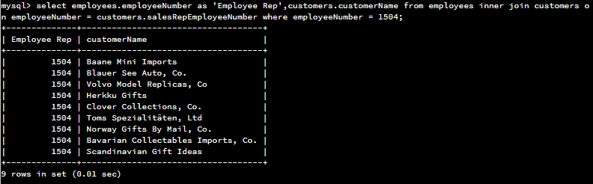

This relationship is a one-many as one sales rep can have many customers.

1. **Retrieve records** for customers who reside in Massachusetts and **identify** **their sales rep and the relationship of entities**. Identify if these entities demonstrate one-to-one or many-to-many relationships.
   1. Remember: SELECT, FROM, INNER JOIN, and WHERE.
   2. Use employee.firstName and employee.lastName in your command.
   3. Identify whether these entities demonstrate one-to-one or many-to-many relationships or one-to-many.

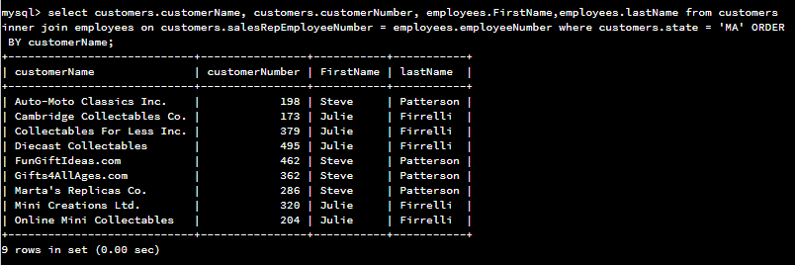

This is a many to one relationship, as there are many customers in MA, but they only have 1 sales rep each.

1. **Add one customer record** with your last name using an INSERT statement. You may use the name of a celebrity or fictional character if you don’t use your own name.
   1. You may use the name of a celebrity or fictional character if you don’t use your own name. Think of this as your signature.
   2. Complete these actions to get to the right place to enter this information: (1) Show databases, (2) use classicmodels, (3) show tables, (4) describe customers;
      1. You should now see all of the fields that you’ll need to fill in to complete this step.
      2. Reference your Module Two lab or resources on how to populate these fields if you need to.
      3. Populate the following fields:

customerNumber

customerName

contactLastName

contactFirstName

phone

addressLine1

addressLine2

city

state

postalCode

country

salesRepEmployeeNumber

creditLimit

* + 1. Run a SELECT statement on the Customers table and capture it in a screenshot.

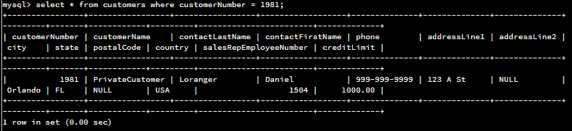

1. **Reflection:** Use the lab environment or the screenshots you’ve worked with for this step. Address the prompts below in your reflection. Write a paragraph in response to each prompt:
   1. **Define how cardinality is applied** to the databases you’ve been working with. Explain why different numbers of records were returned from the different offices.

Each table has different cardinalities, typically many to one but also some none-to-one. As example, there are many products to one order, many orders to one customer (even if not yet placed), but only one employee rep to each customer, and one rep to each office. A customer may exist, but has not yet placed an order.

* 1. **Compare and contrast** the different **queries** you ran and how cardinality applies to them.

Some are many-to-one, but others are one-to-many. Example the sales rep Barry Jones has many customers, while the state MA has many customers, but each one only has a single representative.

* 1. **Describe two** of the crucial **benefits** **of cardinality** in this type of database.

The cardinality can help to identify foreign keys and primary keys and where applicable where to split tables into new tables to minimize duplicity.